

CAPSTONE PROJECT REPORT

Report 1: Project Introduction

WonderTales: Web-Based Interactive Storytelling and Education Platform

SE1909_GROUP4_SUPERVISOR
Full Name | Role | Email | Mobile
Nguyen Cuong Manh | Supervisor | manhnc5@fpt.edu.vn

SE1909_GROUP4_MEMBER
Full Name | Role | Email | Mobile
Mai Nữ Kiều Trinh | Leader
Ngô Minh Nhật | Member
Đặng Đức Minh | Member
Ngô Đức Lương | Member
Phạm Việt Anh | Member

- Hanoi, February 2026 -
Table of Contents
I. Record of Changes 4
II. Glossary and Legend 5
1/ Glossary 5
III. List Figures and Tables 6
2.1 List Figures 6
2.2 List Table 6
IV. Project Introduction 7
1. Overview 7
1.1 Project Information 7
2. Project Background 8
2.1 National Context 8
2.2 Local Context 8
2.3 Why WonderTales Was Built: The Parental Problem 9
2.3.1 Uncontrolled Screen Exposure and Passive Content Consumption 9
2.3.2 Insufficient Parent-Child Bonding Time in the Digital Environment 10
2.3.3 Lack of Safe, Culturally Relevant Educational Content 10
2.4 Introduction about Wondertales 11
2.5 Legal & Regulatory Compliance 12
2.5.1 Child Protection on Digital Platforms 12
2.5.2 Personal Data Protection 12
2.5.3 E-Commerce and Payment Regulation 12
2.5.4 Digital Content and Online Information Management 13
2.5.5 Early Childhood Education Standards 13
3. Existing Systems 14
3.1 LingoKids 14
3.2 Sago Mini Worlds 16
4. Business Opportunity 18
5. Software Product Vision 19
5.1 Major Features 21
6. Project Scope & Limitations 22
6.1 Major Features 23
6.2 Limitations & Exclusions 25
V. References 26

Record of Changes

Date | A*M, D | In charge | Change Description
23/2/2026 | A | NhatNM | Add Template & Content v1.0
23/2/2026 | A,M | NhatNM | Add more Glossary term, Modify section 5 vision actor
26/2/2026 | M | NhatNM | Modify 6. Major Features
1/3/2026 | A | NhatNM | Add Project Background, National Context
6/3/2026 | M | NhatNM | Modify Local Context with references + Existing System ( lingokid)
12/3/2026 | M,D | NhatNM | Change Business Opportunity evidence and content, Delete old business background
15/3/2026 | A,D | NhatNM | Delete old features tree, Add new features tree + table
17/3/2026 | A,M | NhatNM | Add 1 existing system (sago mini world), Modify Software Product Vision , Complete introduction section
19/3/2026 | A,M | NhatNM | Revise platform scope (Flutter mobile + web admin), Expand project background with parental pain points, Add References section
20/3/2026 | A | NhatNM | Add Legal & Regulatory Compliance Section + References
*A - Added M - Modified D - Deleted

Glossary and Legend

1/ Glossary
Acronym | Definition
FE | Feature elements
WTS | Wondertales System
AI | Artificial Intelligence
MVP | Minimum Viable Product
CAGR | Compound Annual Growth Rate
UC | Usecase
CMS | Content Management System
EDA | Event-Driven Architecture

List Figures and Tables

2.1 List Figures

No. | Figure Title | Page
Figure 1 | LingoKids Application Interface | 10
Figure 2 | Sago Mini World Application Interface | 12
Figure 3 | WonderTales Feature Tree | 19

2.2 List Table

No. | Table Title | Page
Table 1 | List of Functional Elements (FE) in the Wondertales System | 20

Project Introduction

1. Overview
WonderTales is a cross-platform interactive storytelling and early education solution designed to bring parents and young children together through meaningful stories, playful learning, and AI-assisted experiences. The platform targets children aged 3-6 years old, combining immersive narratives with educational content to nurture cognitive, emotional, and social development at an early age.

The project was born from a shared concern among our team members: in an increasingly screen-dominated world, children’s screen time is often passive and non-educational. WonderTales reimagines digital content as an active, guided, and emotionally enriching experience - one that parents can confidently share with their children or allow children to explore independently in a safe, moderated environment.

1.1 Project Information

• Project name: Web-Based Interactive Storytelling and Education Platform
• Vietnamese name: WonderTales - Nền tảng Kể Chuyện Tương Tác & Giáo Dục cho Trẻ Em
• Project code: SWD392
• Group name: GROUP4_SE1909_SP26
• Software type: Flutter Mobile Application ,Web Application
• Target Users: Children aged 3-6 and their parents/guardians (mobile); Internal staff - Admin, Content Developer, Moderator (web)

2. Project Background

2.1 National Context
Vietnam is experiencing rapid digital transformation across all sectors, including education and child development. Vietnam has one of the highest rates of smartphone penetration in Southeast Asia, with over 73 million internet users as of 2024. Screen time among children under 8 has significantly increased, particularly following the COVID-19 pandemic. The Vietnamese government's National Digital Transformation Program to 2025 explicitly promotes the development of digital educational content for children as a priority sector [1].

The national education system has increasingly emphasized STEM and early childhood education reform, encouraging schools and families to adopt digital learning tools that are interactive and outcome-oriented. The Vietnamese government’s National Digital Transformation Program to 2025 explicitly promotes the development of digital educational content for children as a priority sector.

Despite this growth, most digital content available to Vietnamese children remains either purely entertaining (lacking educational value) or overly academic (lacking engagement). There is a clear and urgent gap for platforms that blend storytelling, play, and structured learning in a single, safe, and parent-friendly environment.

2.2 Local Context
In Hanoi and other major urban centers of Vietnam, parents - particularly millennial parents - are increasingly aware of the importance of early childhood education and are actively seeking digital tools that support language development, emotional intelligence, and cognitive growth. At the same time, these parents express deep concern about screen safety, unmoderated content, and the risk of children accessing inappropriate material online [19].

Local kindergartens and early learning centers have begun integrating digital tools into their curricula, but the adoption is fragmented and inconsistent due to a lack of locally developed, culturally relevant platforms. Most existing platforms used in Vietnamese schools are imported and adapted from Western contexts, creating a cultural and linguistic mismatch that reduces engagement among young Vietnamese learners [12].

WonderTales directly addresses this local need by offering a platform built with Vietnamese children in mind - featuring culturally familiar storylines, bilingual support (Vietnamese and English), and parental control tools designed for busy Vietnamese families.

2.3 Why WonderTales Was Built: The Parental Problem

2.3.1 Uncontrolled Screen Exposure and Passive Content Consumption

Vietnamese children are beginning to use digital devices at an average age of 9 months - significantly earlier than the global average - and over 70% of children under 5 in urban areas access the internet daily [2]. Yet the vast majority of this screen time is passive: children primarily watch content without being prompted to respond, decide, or engage.

Research published in JAMA Pediatrics (2023) shows that children with high passive content consumption are significantly more likely to experience language development delays compared to peers with moderate, interactive usage [3]. Studies from Harvard Health and Mount Elizabeth Hospital Vietnam (2024) further confirm that fast-paced, one-directional screen content impairs concentration and reduces cognitive test scores in young children [5]. Vinmec International Hospital (2024) notes that for children under four, every additional hour of passive screen viewing is associated with fewer words learned - a direct consequence of reduced parent-child verbal interaction [6].

The American Academy of Pediatrics recommends no more than one hour of high-quality screen time per day for children aged 2-5, as prolonged exposure is associated with negative outcomes in attention, language development, and socio-emotional skills [16]. Clinical and psychological research further documents that excessive screen time leads to difficulties in emotional regulation, empathy, and social interaction [9].

In our survey (n=50), 42% of parents reported that their children primarily watch screens without meaningful interaction, and 48% struggled to control what content their children accessed. This creates a specific parental pain: parents are not opposed to digital devices per se, but they cannot find platforms where screen time is genuinely active, moderated, and developmental.[20]

2.3.2 Insufficient Parent-Child Bonding Time in the Digital Environment

Work pressure and the pace of modern urban life have significantly reduced the time parents can spend in direct, meaningful interaction with their children. According to a report by Lurie Children's Hospital (2025), approximately 60% of parents admit to feeling guilty about using electronic devices as a "digital babysitter" to free up personal time [7]. Among Vietnamese parents surveyed by VnExpress (2020), 78% reported feeling that they did not spend enough quality time with their children [8].

Most existing digital platforms are designed for children to use alone - inadvertently widening the gap between parent and child during a critical developmental window. Research emphasizes that content quality and parent-child interaction during screen time matters far more than screen time duration alone [4]. Our survey confirmed this: 38% of parents listed "reduced family bonding time" as their top concern about their child's device usage. Parents do not want a babysitter app. They want a platform that invites them in - one where storytime, minigames, and shared experiences are built for two.

2.3.3 Lack of Safe, Culturally Relevant Educational Content

Despite a rapidly growing EdTech market - Vietnam's EdTech sector is growing at a 44.3% CAGR, ranking among the top 10 globally [10] - Vietnam's ecosystem remains dominated by K-12 test-preparation tools and foreign language learning apps. A clear gap exists in high-quality, locally developed, child-safe storytelling platforms for preschoolers [10][12]. Vietnam has over 5 million preschool-aged children [18], yet most international platforms in use are not localized for Vietnamese children - their characters, storylines, and cultural references feel foreign, reducing emotional engagement.

Furthermore, 50% of parents in our survey [20] expressed concern that their children were exposed to age-inappropriate content, and risks of exposure to harmful content online for Vietnamese children remain a documented concern [19]. Parents are willing to pay for a solution - education accounts for 47% of urban household spending in Vietnam [11] - but only if they trust it. Content safety, moderation, and cultural relevance are non-negotiable requirements that current market offerings consistently fail to deliver together.

These three problems - passive screen exposure, weakened parent-child bonding, and the absence of safe and locally relevant content - are the direct foundation upon which WonderTales was designed. Every feature, every moderation workflow, and every architectural decision in this project traces back to solving one or more of these documented parental pain points.

2.4 Introduction about Wondertales

WonderTales is a cross-platform interactive storytelling and education solution consisting of two tightly integrated components: a Flutter-based mobile application for children and parents, and a web-based administration portal for internal staff. Each story invites kids to actively participate by making choices, solving small challenges, and exploring imaginative worlds, while gently teaching valuable life lessons such as kindness, honesty, and problem-solving.

AI in WonderTales acts only as a supportive assistant, with all content carefully moderated and no open chat features, ensuring children cannot communicate freely with other users. Built with child safety and ease of use in mind, the mobile app is fully accessible on Android without any complex setup, allowing parents to join their children in shared storytime or confidently let kids explore on their own.

With engaging visuals, age-appropriate content, and guided interactions, WonderTales transforms storytelling into a fun, educational experience that strengthens family bonds and nurtures young minds. The platform’s three core modules - AI Interactive Storytelling, Thematic Learning Lessons, and Parent-Child Minigames - work together to create a holistic early childhood digital experience. Behind the scenes, a dedicated Content Developer team manages all story assets and learning curriculum through a built-in web CMS, while Moderators ensure every piece of content meets strict child safety standards before it reaches young users.

2.5 Legal & Regulatory Compliance
WonderTales operates within a clearly defined legal and regulatory framework established by the Vietnamese government. The following legislation directly governs the platform's design decisions, content moderation workflows, data handling practices, and commercial operations.

2.5.1 Child Protection on Digital Platforms
Nghị định 56/2017/NĐ-CP, which provides detailed implementation of the Law on Children, explicitly requires digital platforms accessible to minors to implement content filtering, moderation mechanisms, and reporting channels for harmful content [21]. This regulation is the direct legal basis for WonderTales' mandatory Moderator review workflow (LI-7), the prohibition of open chat features, and the AI Story Assistant's restriction to pre-approved response boundaries only (LI-1). No content may reach child users without passing through a human moderation checkpoint - a business rule enforced at the architecture level, not merely as a product choice.

2.5.2 Personal Data Protection
Nghị định 13/2023/NĐ-CP on Personal Data Protection requires explicit consent before collecting, processing, or storing personal data, with heightened obligations when the data subject is a minor [22]. For WonderTales, this means: parental consent must be obtained before a child profile is created; data collected on children (name, age, listening history, activity logs) must be stored securely and used solely for the stated educational purpose; and users must be provided with clear data deletion mechanisms. This regulation directly shapes FE-02 (Parental Management) and the platform's account registration flow in FE-01.

2.5.3 E-Commerce and Payment Regulation
Nghị định 52/2013/NĐ-CP as amended by Nghị định 85/2021/NĐ-CP on e-commerce requires platforms offering paid subscription services to maintain transparent pricing disclosure, provide electronic invoices, and offer a clear cancellation and refund policy [23]. Thông tư 09/2020/TT-BCT further regulates electronic transactions in commercial activities [24]. These regulations govern the design of FE-05 (Subscription & Payment Management), including transaction history records, invoice generation, and renewal/cancellation handling.

2.5.4 Digital Content and Online Information Management
Nghị định 72/2013/NĐ-CP on the management of internet services and online information requires that platforms publishing digital content to Vietnamese users comply with content standards and maintain audit logs of published material [25]. This regulation reinforces the Content Developer → Moderator → publish pipeline enforced in FE-06, and supports the platform's AI interaction logging requirement. Additionally, Luật Sở hữu trí tuệ 2005 (sửa đổi 2022) on intellectual property requires that all graphic assets, audio recordings, and story scripts uploaded by Content Developers be properly licensed or originally produced [26]. This is enforced through the asset submission workflow in the CMS, where Content Developers are required to declare content ownership at the point of upload.

2.5.5 Early Childhood Education Standards
Luật Giáo dục 2019 and Thông tư 52/2021/TT-BGDĐT on the application of information technology in early childhood education establish standards for digital learning content targeting preschool-aged children [27]. While WonderTales does not currently target institutional school accounts (LI-6), compliance with these standards ensures the platform's thematic learning lessons and AI storytelling content are pedagogically aligned with Vietnam's national early childhood curriculum framework - strengthening the platform's credibility and positioning it for future school partnership expansion.

3. Existing Systems

3.1 LingoKids

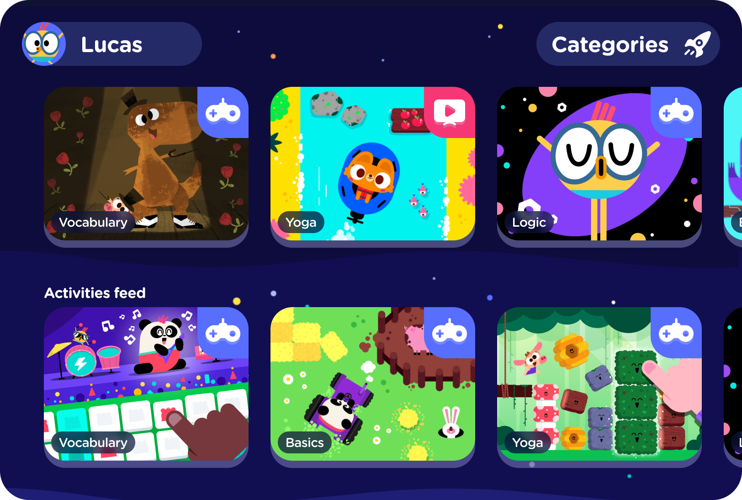

Figure 1: LingoKids Application Interface

LingoKids is a comprehensive English-learning app for children aged 2-8, developed by Monkimun. It offers a game-based curriculum where children learn English through songs, games, and activities centered around a family of lovable animal characters. The platform has been downloaded over 100 million times globally and is available on iOS, Android, and web browsers.

Link: https://lingokids.com/

System Actor:
• Child - learns through games and activities
• Parent - monitors progress
• Admin - manages content and platform

Features:
• 700+ structured learning activities
• Songs, games, books
• Progress dashboard for parents
• Offline mode & English-language focused curriculum

Strengths:
• Rich content library
• Strong parental monitoring
• High engagement for young children
• Proven pedagogical method

Weakness/Gap:
• Focused exclusively on English learning
• No AI interactive storytelling
• No parent-child co-play minigames
• Content not culturally adapted for Vietnamese users
• Subscription cost may be a barrier for Vietnamese families

3.2 Sago Mini Worlds

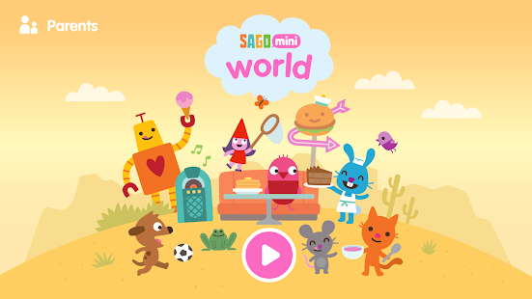

Figure 2: Sago Miniworlds Application Interface

Sago Mini World is an expansive open-play platform for preschoolers aged 2-5, developed by Sago Mini. It features an award-winning collection of creative games and activities led by a cast of iconic animal characters. With over 40 million downloads globally, the platform emphasizes curiosity and imaginative play. It is available on iOS, Android, and Amazon platforms.

Link: https://sagomini.com/

System Actor:
• Child - plays open-ended games
• Parent - manages subscription and screen time
• Admin - manages content releases

Features:
• 35+ standalone mini apps in one subscription;
• Open-ended creative play
• Ad-free and child-safe
• Simple, intuitive interfaces for toddlers

Strengths:
• Excellent child safety design
• Joyful low-pressure experience
• Wide variety of play themes
• Trusted by parents globally

Weakness/Gap:
• No structured educational content or learning outcomes
• No AI-driven storytelling
• No parent-child interactive mode
• Not localized for Vietnamese market
• Does not include narrative-based or thematic lesson content

4. Business Opportunity
The global EdTech market reached approximately USD 144.64 billion in 2023 and is projected to reach USD 598.82 billion by 2032, growing at a CAGR of approximately 17.10% [17]. Southeast Asia, and Vietnam in particular, is one of the fastest-growing markets in this segment, with Vietnam's EdTech sector growing at a 44.3% CAGR [10].

Vietnam has over 5 million preschool-aged children [18], and education spending in Vietnam grew from USD 23.6 billion to USD 32.8 billion between 2017 and 2022 at a 7% CAGR, with EdTech market revenue projected to reach USD 364.7 million in 2024 [11]. Despite this, Vietnam's EdTech ecosystem remains heavily focused on K-12 and language learning, leaving a clear gap in high-quality interactive storytelling for preschoolers [10][12].

Currently, the market for child-focused educational platforms in Vietnam faces a significant structural gap: most popular platforms are either (1) purely entertainment apps with no educational framework, or (2) rigid e-learning platforms with low engagement. Neither adequately serves the growing demand from Vietnamese parents who want something simultaneously safe, educational, and genuinely fun for their young children.

While platforms like LingoKids and Sago Mini World serve portions of this market, none offer a combined experience of AI-enhanced interactive storytelling, structured thematic learning for ages 3-6, and collaborative parent-child play. WonderTales is uniquely positioned to fill this gap. The proposed product offers the following key opportunities:

1. Serve the underserved 3-6 age demographic with culturally relevant, bilingual content designed specifically for Vietnamese families.
2. Leverage AI storytelling to create personalized, dynamic narratives that adapt to each child’s choices, increasing engagement and replayability.
3. Provide parents with peace of mind through a fully moderated, ad-free environment with no open communication channels.
4. Generate sustainable revenue through a freemium model, offering basic stories for free and premium content via affordable monthly or annual subscriptions.
5. Build long-term brand loyalty by establishing WonderTales as the trusted digital companion for early childhood learning in Vietnam.

The absence of a locally built, culturally relevant, AI-powered storytelling platform for young Vietnamese children represents both a market gap and a genuine social need. WonderTales is positioned to address both simultaneously.

5. Software Product Vision

WonderTales is envisioned as Vietnam’s leading interactive storytelling and early education solution - a trusted digital space where imagination meets learning, and where parents and children can explore, grow, and bond together through the power of story.

The system will serve as a unified, child-safe platform delivered across two specialized interfaces: a Flutter mobile application for families (children and parents), and a web-based administration portal for internal operational roles. This split architecture ensures that the child-facing experience is optimized for touch-based, mobile-first interactions, while the content management and moderation workflows benefit from the richer screen real estate and tooling available on the web.

• For children (aged 3-6): Provide an immersive, joyful, and safe digital experience that sparks curiosity, builds language skills, develops emotional intelligence, and teaches core values through interactive stories and play-based learning activities

• For parents and guardians: Offer a trustworthy, ad-free platform with transparent parental controls and progress tracking, allowing parents to confidently give their children screen time that is both enriching and safe. Parents can also actively participate through shared storytime and co-play minigame sessions.

• For Content Developers: Provide a powerful, intuitive Content Management System (CMS) that allows developers to upload graphic assets, voiceovers, sound effects, and multilingual story scripts, manage learning path categories, and preview stories in a sandbox mode before publishing - all without requiring engineering involvement.

• For Moderators: Equip the moderation team with a dedicated review and audit workflow to approve pending stories, check visual and audio assets against child safety standards, monitor AI response logs for inconsistencies, and resolve user-reported content issues - ensuring every piece of content that reaches children has passed a rigorous human safety review.

For Administrators: Offer a robust backend dashboard to monitor real-time system performance, manage global user databases, and configure API integrations. Administrators can oversee automated data backups, manage subscription tiers, and deployment pipelines to ensure high availability and scalability across all regions.

Unlike existing platforms such as LingoKids (which focuses exclusively on English language learning) or Sago Mini World (which prioritizes free play without structured educational outcomes), WonderTales uniquely integrates all three pillars: AI-enhanced narrative, thematic education, and family co-play. In the long term, WonderTales envisions expanding its story library, introducing user-generated story elements, and partnering with Vietnamese schools and kindergartens to integrate platform content into early childhood curricula.

5.1 Major Features
WonderTales is built on an Event-Driven Architecture (EDA) pattern. In this model, every significant user action - a child making a story choice, completing a lesson activity, finishing a minigame, or a parent adjusting settings - is emitted as a discrete event. These events are captured, processed, and broadcast to the relevant system components asynchronously, enabling the platform to respond in real time without tight coupling between modules.

This architecture is a natural fit for WonderTales for several reasons. First, the interactive storytelling module requires immediate, low-latency responses when a child selects a story branch - the AI Story Assistant must react to user-triggered events and deliver the next narrative segment seamlessly. Second, the Parental Dashboard relies on receiving a continuous stream of activity events from all three core modules (storytelling, lessons, and minigames) to compile up-to-date progress data without requiring manual data polling. Third, the Parent-Child Minigame module benefits from real-time event synchronization between two users sharing the same session.

Key benefits of Event-Driven Architecture for WonderTales include: loose coupling between modules (each module publishes/consumes events independently); real-time responsiveness for story branching and minigame interactions; scalability as new features can subscribe to existing event streams without modifying core logic; and auditability since all AI interactions and user actions are logged as traceable events, supporting the platform's parental transparency commitment.

6. Project Scope & Limitations

This project was developed over a 6-week capstone period by a team of five members. During the initial research and design phase, many potential features were identified - including adaptive learning paths, live parent-teacher communication tools, and multi-language content expansion. However, to ensure the project remained achievable, testable, and polished within the given timeframe, the team made a deliberate decision to focus on three high-impact core modules.

The project adopts a value-driven MVP approach - concentrating on delivering a high-quality solution that directly serves two user groups via the Flutter mobile app parents (via the Parental Dashboard and co-play features) and children aged 3-6 (via AI storytelling, thematic lessons, and minigames). Internal operational roles - Admin, Content Developer, and Moderator - are served via a dedicated web portal accessible through any standard desktop browser.

6.1 Major Features

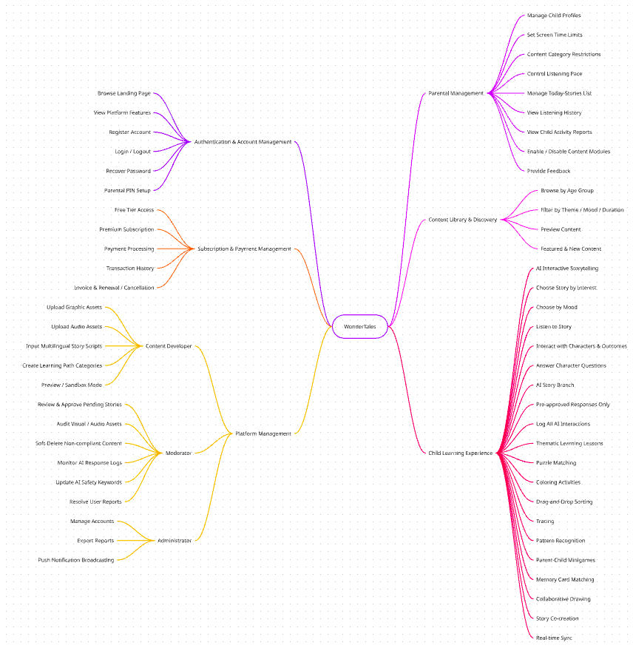

Figure 3: WonderTales Feature Tree - Detail

FE Code | Feature Name | Description
FE-01 | Authentication & Account Management | Handles account entry points for all roles. Guests can browse the landing page before registering. Includes: registration (email, phone number, password), login/logout, and password recovery.
FE-02 | Parental Management | Parents manage child profiles (add, view, update, delete) using only the child's name. Per-child settings include screen time limits, content restrictions, and listening pace. Parents curate a today-stories list per child (add, update, delete) and can view listening history and activity reports.
FE-03 | Content Library & Discovery | A browsable, filterable library of stories, lessons, and minigames organized by age group, theme, mood, and duration. Featured and newly published content is highlighted on the home screen.
FE-04 | Child Learning Experience | Three child-facing experiences: AI Interactive Storytelling - children choose stories by interest or mood (happy, sad, angry, sleepy), listen interactively, answer character questions, and influence outcomes via a moderated AI assistant (pre-approved responses only, no open chat). Thematic Learning Lessons - wordless visual activities for ages 3-6 including puzzle matching, coloring, drag-and-drop sorting, tracing, and pattern recognition. Parent-Child Minigames - cooperative same-device co-play games with real-time synchronization via Event-Driven Architecture.
FE-05 | Subscription & Payment Management | Manages Free and Premium subscription tiers. Handles payment processing, transaction history, invoice generation, and renewal/cancellation. Free tier offers limited content; Premium unlocks the full library.
FE-06 | Platform Management | Back-office module for three internal roles. Content Developers upload assets (graphics, audio, story scripts), create learning path categories, and preview stories before submission. Moderators review and approve stories, audit assets for child safety, soft-delete non-compliant content, monitor AI logs, and resolve user reports. Administrators manage internal accounts, export reports (statistics, transactions, logs, feedback), and broadcast push notifications.

6.2 Limitations & Exclusions

LI-1: The AI Story Assistant will operate only within pre-defined story templates and moderated content boundaries. It will not generate open-ended narrative content dynamically, and children will have no ability to input free-form text.
LI-2: The platform will initially support Vietnamese and English language content only. Other languages are out of scope for this capstone phase.
LI-3: Real-time multiplayer functionality is excluded. Parent-child minigames are designed for same-device co-play only in this initial version.
LI-4: AI-driven mood-based story recommendations (e.g., automatically detecting a child's emotional state and selecting a matching story) are not included in this phase. Mood-based listening (happy, sad, angry, sleepy) is supported as a manual child-selected filter only, not an automated recommendation engine.
LI-5: Offline mode is not supported in the current scope. WonderTales requires an active internet connection to access stories, lessons, and minigames, as all content is served and moderated through the web platform.
LI-6: School or institution-level accounts (bulk licensing, classroom management tools) are not included. The platform targets individual family subscriptions only.
LI-7: Content Developer accounts cannot publish stories directly to production. All content submitted through the CMS must pass through the Moderator review and approval workflow before becoming visible to end users.

References
- [1] Vietnam Ministry of Information and Communications. (2020). National Digital Transformation Program to 2025, orientation to 2030. Hanoi: Government of Vietnam. https://asemconnectvietnam.gov.vn/default.aspx?ZID1=14&ID8=99391&ID1=2
- [2] VnExpress. (2023). Trẻ em Việt Nam sử dụng Internet sớm hơn trung bình toàn cầu. Retrieved from https://vnexpress.net/tre-em-viet-duoc-dung-dien-thoai-som-4-nam-so-voi-the-gioi-4580136.html
- [3] Madigan, S., Browne, D., Racine, N., Mori, C., & Tough, S. (2023). Association Between Screen Time and Children’s Performance on a Developmental Screening Test. JAMA Pediatrics, 173(3), 244-250. https://jamanetwork.com/journals/jamapediatrics/fullarticle/2808593
- [4] Hirsh-Pasek, K., Zosh, J. M., Golinkoff, R. M., Gray, J. H., Robb, M. B., & Kaufman, J. (2020). Putting Education in “Educational” Apps: Lessons from the Science of Learning. JAMA Pediatrics. https://jamanetwork.com/journals/jamapediatrics/fullarticle/2762864
- [5] Mount Elizabeth Hospital Vietnam. (2024). Screen time and cognitive development in Vietnamese preschool children: Clinical observations. Ho Chi Minh City: Mount Elizabeth.
- [6] Vinmec International Hospital. (2024). Ảnh hưởng của thời gian sử dụng màn hình đến sự phát triển ngôn ngữ của trẻ. Hanoi: Vinmec. Retrieved from https://www.vinmec.com/vie/bai-viet/su-dung-thiet-bi-dien-tu-qua-nhieu-co-gay-hai-cho-nao-bo-cua-tre-vi#:~:text=S%E1%BB%AD%20d%E1%BB%A5ng%20thi%E1%BA%BFt%20b%E1%BB%8B%20%C4%91i%E1%BB%87n,Vinmec
- [7] Lurie Children’s Hospital. (2025). Screen time, parental guilt, and children’s digital media use in 2025. Chicago: Ann & Robert H. Lurie Children’s Hospital of Chicago. https://www.luriechildrens.org/en/blog/screen-time-2025/
- [8] VnExpress. (2020). 78% phụ huynh Việt Nam cảm thấy có lỗi vì thiếu thời gian bên con. Retrieved from https://vnexpress.net/danh-thoi-gian-chat-luong-ben-con-gop-phan-giup-tre-phat-trien-toan-dien-4130772.html
- [9] Domingues-Montanari, S. (2017). Clinical and psychological effects of excessive screen time on children. Journal of Paediatrics and Child Health, 53(4), 333-338. https://pubmed.ncbi.nlm.nih.gov/40055171/
- [10] Nextrans. (2023). Sách trắng EdTech Việt Nam 2023. Hanoi: Nextrans. https://nextrans.vn/edtech-viet-nam-2023/
- [11] FiinGroup. (2024). Vietnam Education Spending Report 2024. Hanoi: FiinGroup.
- [12] Tuổi Trẻ. (2023). Khoảng trống trong nền tảng EdTech cho trẻ mầm non tại Việt Nam. Retrieved from https://tuoitre.vn
- [13] OECD. (2019). Curiosity as a driver of early cognitive development. OECD Education Today. Paris: OECD Publishing.
- [14] ScienceDirect. (2024). Integrating lines of research on children’s curiosity-driven learning: A large-scale review. Learning and Individual Differences. https://www.sciencedirect.com
- [15] PwC. (2022). PwC Media Outlook - Children’s Digital Content Segment. London: PricewaterhouseCoopers.
- [16] American Academy of Pediatrics. (2016). Media and Young Minds. Pediatrics, 138(5). https://publications.aap.org
- [17] Straits Research. (2024). EdTech Market Size, Share & Trends Analysis Report 2024-2032. Retrieved from https://straitsresearch.com
- [18] The Leader Vietnam. (2023). Việt Nam có hơn 5 triệu trẻ trong độ tuổi mầm non. Retrieved from https://theleader.vn
- [19] RMIT University Vietnam. (2024). Online safety for children in Vietnam: Risks, exposures, and parental awareness. Ho Chi Minh City: RMIT.
- [20] Group 4 - SE1909. (2026). Khảo sát nhu cầu ứng dụng kể chuyện và học tập cho trẻ em [Survey data, n=50]. Google Forms. https://docs.google.com/forms/d/1sFag-jrVjrwmFX-rI44bfQXl5MDKy_vScujwN_Gl0Rk/edit
- [21] Chính phủ Việt Nam. (2017). Nghị định 56/2017/NĐ-CP quy định chi tiết một số điều của Luật Trẻ em. Hanoi: Chính phủ. https://vanban.chinhphu.vn/?pageid=27160&docid=189758&classid=1&orggroupid=2
- [22] Chính phủ Việt Nam. (2023). Nghị định 13/2023/NĐ-CP về bảo vệ dữ liệu cá nhân. Hanoi: Chính phủ. https://vanban.chinhphu.vn/?pageid=27160&docid=207759
- [23] Chính phủ Việt Nam. (2021). Nghị định 85/2021/NĐ-CP sửa đổi, bổ sung một số điều của Nghị định 52/2013/NĐ-CP về thương mại điện tử. Hanoi: Chính phủ. https://vanban.chinhphu.vn/default.aspx?pageid=27160&docid=204191
- [24] Bộ Công Thương. (2020). Thông tư 09/2020/TT-BCT quy định về hoạt động kiểm tra, giám sát thương mại điện tử. Hanoi: Bộ Công Thương. https://chinhphu.vn/default.aspx?pageid=27160&docid=200059
- [25] Chính phủ Việt Nam. (2013). Nghị định 72/2013/NĐ-CP về quản lý, cung cấp, sử dụng dịch vụ internet và thông tin trên mạng. Hanoi: Chính phủ. https://vanban.chinhphu.vn/?pageid=27160&docid=168699
- [26] Quốc hội Việt Nam. (2022). Luật Sở hữu trí tuệ sửa đổi 2022. Hanoi: Quốc hội. https://vanban.chinhphu.vn/?pageid=27160&docid=206240&classid=1&orggroupid=1
- [27] Bộ Giáo dục và Đào tạo. (2021). Thông tư 52/2021/TT-BGDĐT về ứng dụng công nghệ thông tin trong hoạt động giáo dục mầm non. Hanoi: Bộ GD&ĐT. https://chinhphu.vn/default.aspx?pageid=27160&docid=203047

